What’s Been Happening - Update for 2014 and beyond

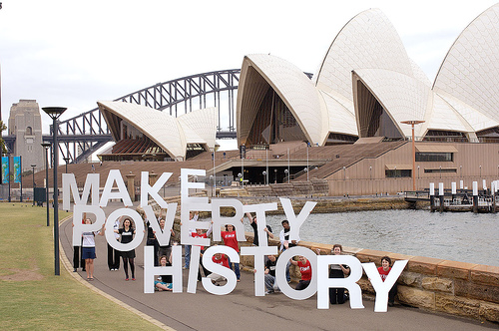
Special Projects
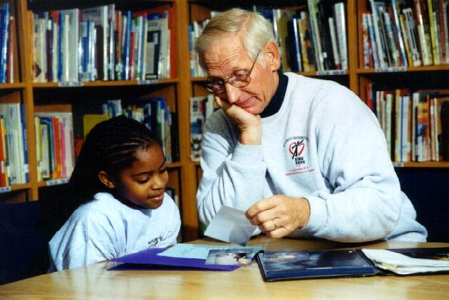

- Kids Hope Northern Territory - Our partnership with World Vision to financially and relationally support the launch of Kids Hope into the Northern Territory was completed at the beginning of this year. The program is now up and running successfully in around 5 churches located in Darwin and Alice Springs mentoring to those children most in need. Each time members from our church have visited the NT we have been welcomed and been able to share stories of encouragement about our experiences mentoring the kids. This has been a great joy for all involved.

- Kids Hope Mona Vale Primary School - We have now been mentoring at the school since Term 2 2013 and the feedback we have received from them has been nothing but positive. While we struggled to initially get the school interested in the program, God opened the door with the new principal who invited us in at the end of 2012. Since then we now have 21 trained mentors - 19 assigned a child and another awaiting assignment with the other 2 acting as relieving mentors. Mentoring is about spending an hour each week with the child and being a stable positive adult influence in their life, someone they can trust. Most of our mentors have been with their child since the beginning and many have commented on how their relationships have been blossoming.

One of the school's deputy principals said that she knows all the kids in the program and has noticed an improvement in every one of them. All our mentors now comment on how welcoming all the staff and teachers are and how the relationship with the school has been transformed. During the year we had our first afternoon tea to meet the parents and this too was a great success and allowed us to forge greater relationships.

With the majority of mentored children coming into the program being boys, we desperately need more male mentors to provide a positive male influence so if you can give up just one hour a week to make a difference in a child's life, please contact Julienne Jones.

 | Nungalinya College  Empowering Indigenous Christians

- Nungalinya Christmas Gift Cards - late last year in support of Nungalinya College in the Northern Territory we ran a fund raising program to help support the work of the college in training Aboriginal & Torres Strait Islander people as Christian leaders in their communities. Thanks to everyone we raised over $4,300 and with an additional donation from out N2239 account, we were able to give the college $8,000. As you may know, as part of government cutbacks across the board, the college lost $180,000 of its funding annually. With this in mind, we will again be promoting the Christmas Gift Cards and we hope you will be generous with your support.

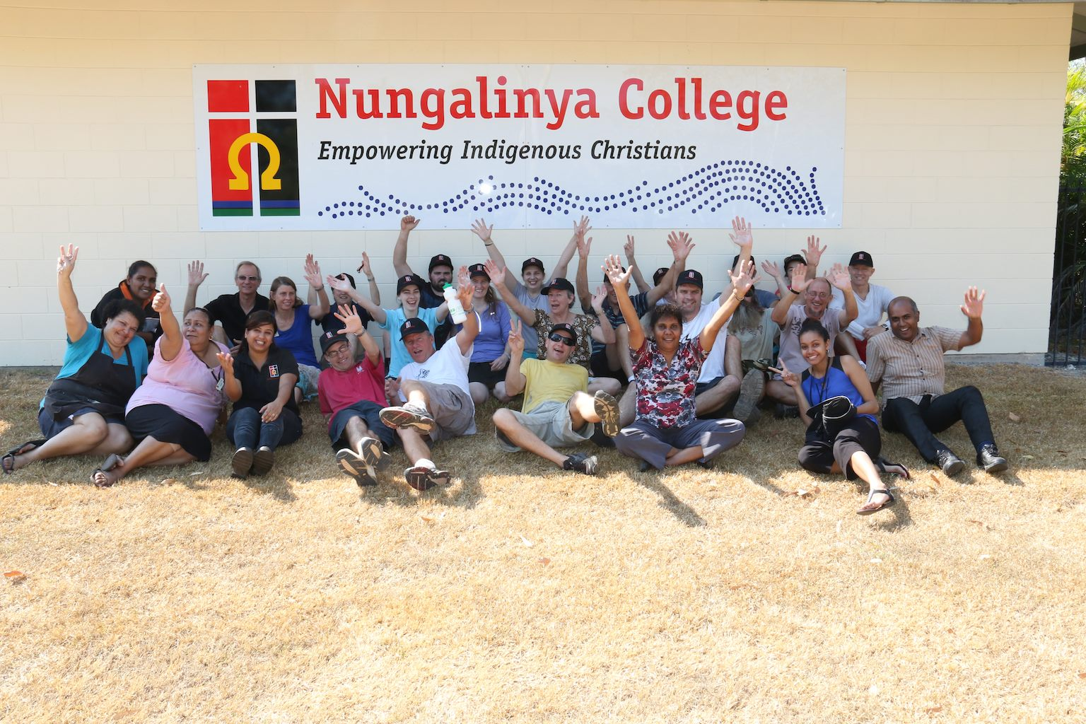

- Nungalinya Working Bee (Darwin) - Late June this year, 16 volunteers from our church went to the college for a week to do basically anything that was needed. Just as the bible talks about the body of Christ with all its parts being necessary (1 Corinthians 12:12-31), it was amazing how God used us to serve the college and assist them improve the facilities for the students. Our team helped build their web site, catalogued their library, painted class rooms and office areas, built and welded fences and completed a massive amount of gardening. We went as a group from various age groups and different church services, many not knowing the others well. We came back enriched by being able to serve the college and through the relationships we built both within our group as well as with the college staff. Everyone who went said they would go again so we are planning another working bee to the college in 2015.

As a result of this visit, Gordon Stokes returned to the college in October with his wife Toni in order to research more into indigenous health issues such as Diabetes and Kidney failure. While there he provided medical advice to the students who will be able to pass this information on to their communities when they return home. Toni was also unexpectedly called upon to run the crèche due to staff illness which was very appreciated.



- World Vision 40 Hour Famine and the Pittwater Famine Village - As in previous years, our church supported the World Vision 40 Hour Famine through the creation of the Pittwater Famine Village to encourage everyone in our community to be involved. It was absolutely fantastic to see Mona Vale Primary School and Loquat Valley Prep School get right behind these effort with all students participating by giving up something to raise funds and awareness for the poor. We also had an Under 14 girls team from Pittwater Soccer club involved and we hope to reach out further next year.

We hosted the break the famine lunch at Mona Vale Village Park and thanks to God who answered our prayers by stopping the (torrential) rain and bringing out the sun just in time to allow us to continue. We raised around $25,000 for the poor in Rwanda. With your help we hope to be able to continue to serve God in this manner and his people who are struggling through poverty and adversity wherever they are. If you would like to be involved, please let Mark Corbett-Jones know.

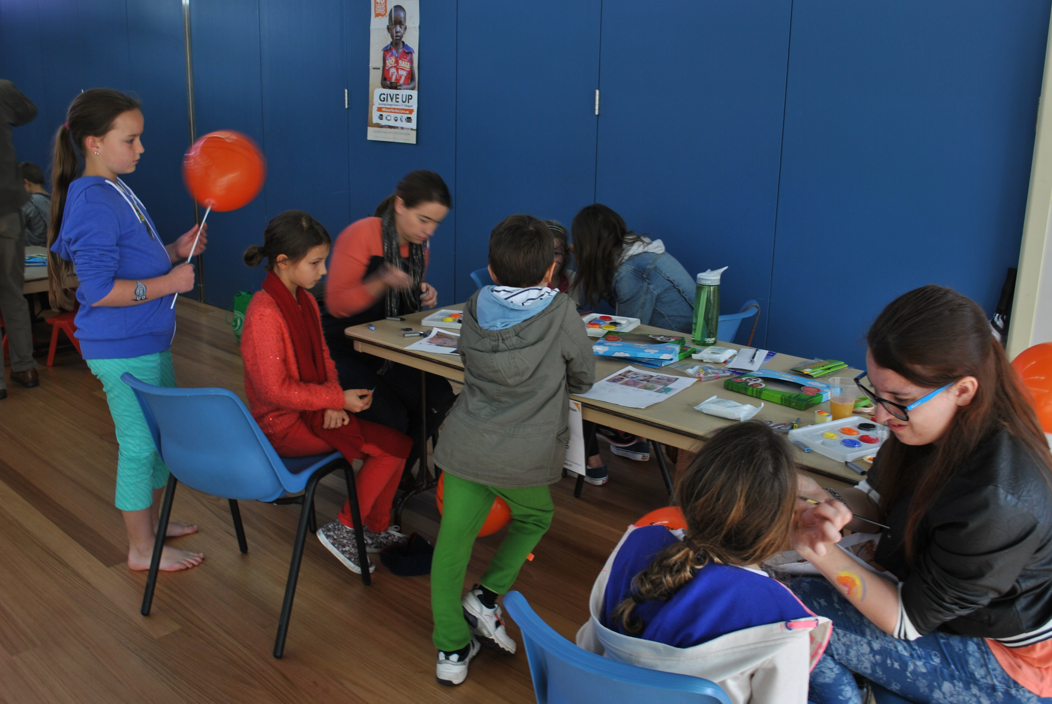

- Child sponsorship - currently the 6pm service sponsor 3 children through World Vision and the Ladies Fellowship Group sponsor an additional 2. Child sponsorship helps the whole community in which the kids live. World Vision’s goal is to teach communities to be self sustaining and resilient by improving education, hygiene, farming techniques and advocacy skills. With your help we can continue this great ministry and possible expand it to cover additional children.

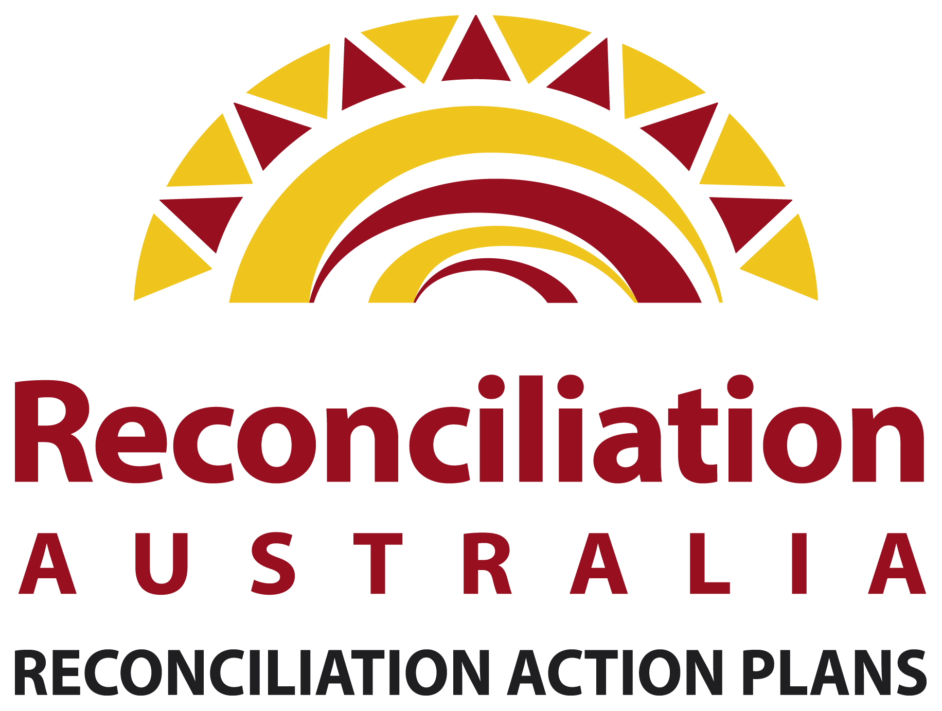

- RAP - As part of our belief in building relationships with Aboriginal and Torres Strait Islander peoples, we developed a Reconciliation Action Plan (RAP) to help break down barriers and to be better informed about our nation's first people. We were actually the first church to do so and were approached by Reconciliation Australia and World Vision to build a better template to allow other churches to participate. This template was released earlier this year and we will need to adapt our RAP to this new format during 2015.

Summary - thank you everyone who has been part of our church's efforts in serving our community. Whether through your prayers, your physical or your financial support, it all makes a difference and is very much appreciated. Our God is being glorified and his people are being loved and cared for.

While we know that we are saved through God's grace to us and not by anything we can do on our own we also know that God calls us to serve him. If you are interested in being involved in any of the above projects, please contact me. Mark Corbett-Jones N22:39 Coordinator (ph 9999 2062)

For we are God's handiwork, created in Christ Jesus to do good works, which God prepared in advance for us to do. (Ephesians 2:10)



